📘 Titanic Survival Analysis – 5-Minute Report

1. Introduction
The Titanic dataset provides information about 891 passengers aboard the RMS Titanic.
The objective of this project is to analyze the key factors that influenced survival, including sex, passenger class, age, and port of embarkation.
Python (Google Colab) was used for data cleaning, analysis, and visualization.

2. Dataset Overview
- Total passengers: 891
- Survival column: 0 = Not Survived, 1 = Survived
- Dataset contains 12 columns such as Age, Sex, Fare, Pclass, Embarked, etc.

3. Data Cleaning
The following cleaning steps were performed:
- Age: Missing values filled using the median age.
- Embarked: Missing values filled using the most frequent port (mode).
- Cabin: Dropped because 687 values were missing.
- Final dataset had no missing values.

4. Key Insights (Survival Rates)

4.1 Overall Survival Rate
- 38.38% of passengers survived.

4.2 Survival by Gender
Gender | Survival Rate
Female | 74.2%
Male | 18.8%
✔ Women had a significantly higher chance of survival.

4.3 Survival by Passenger Class
Class | Survival Rate
1st Class | 62.9%
2nd Class | 47.3%
3rd Class | 24.2%
✔ Higher class = higher survival probability.

4.4 Survival by Embarkation Port
Port | Description | Survival Rate
C | Cherbourg | 55.3%
Q | Queenstown | 38.9%
S | Southampton | 33.9%
✔ Passengers who boarded from Cherbourg had the highest survival rate.

4.5 Age-Based Insight
- Survivors tended to be slightly younger on average.
- Many non-survivors belonged to the adult male 20–40 age group.

5. Visualizations
The following charts were generated using Python:
- Histogram showing Age distribution (survived vs not)
- Bar chart: Survival by Gender
- Bar chart: Survival by Passenger Class
- Bar chart: Survival by Embarked Port
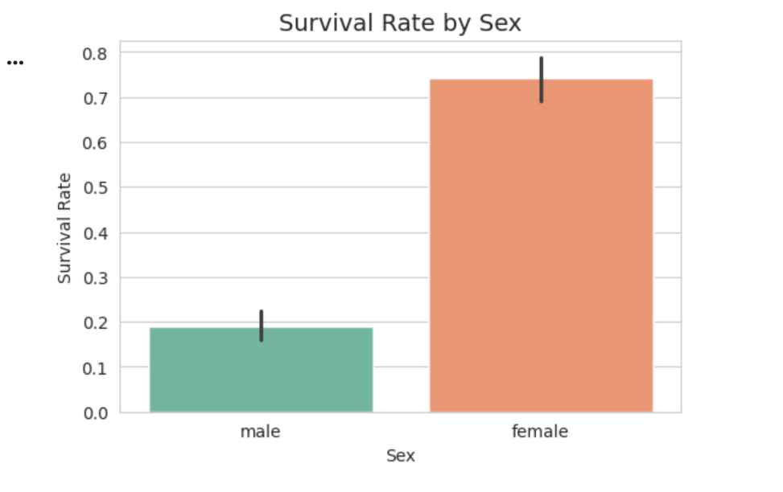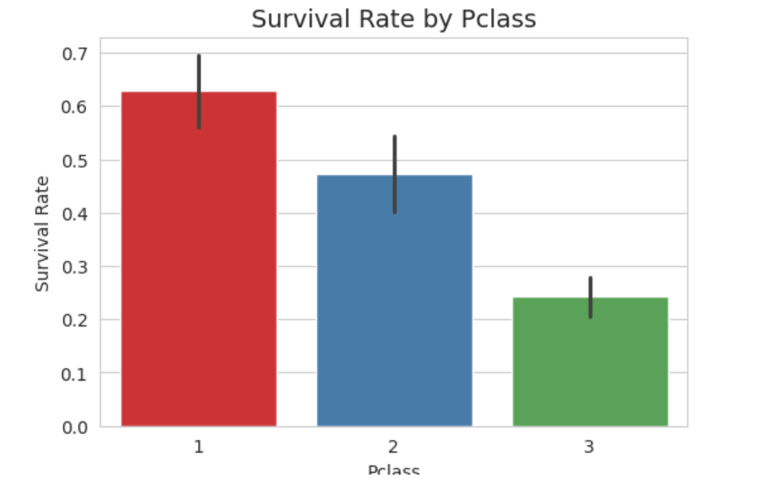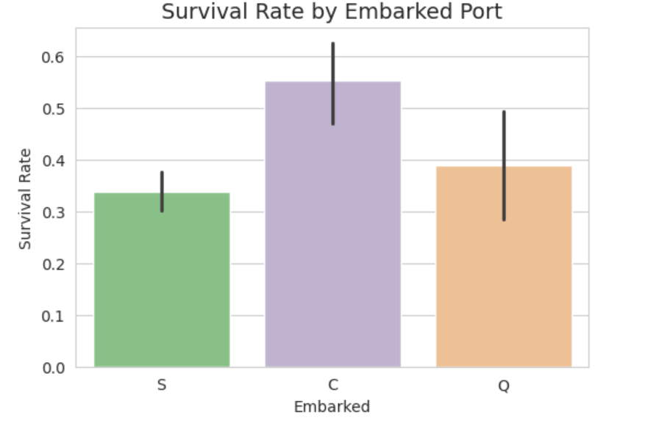

6. Conclusion
The analysis clearly shows that gender and passenger class played a major role in survival.
Women and children, especially in 1st class, had the highest chances of survival.
Passengers from Cherbourg also had relatively higher survival rates.
This project demonstrates how data analysis can uncover meaningful patterns from real-world historical events.

